CREATING RESOURCES – ADDING DATA (POST)

- Edit RestaurantsController.cs
  - Add new HttpPost method
  - Create a new action name CreateRestaurant()
  - Add FromBody attribute
  - Use create method that we will define in the IRestaurantsService.cs
- Create a new dto to create the restaurant called CreateRestaurantDto.cs
  - Create in Restaurants.Application/Restaurants/Dtos
  - Copy Restaurant and RestaurantDto entity for certain column that we want
  - Make sure public class
- Edit RestaurantsProfile.cs
  - Add CreateMap and make sure it maps from CreateRestaurantDto to Restaurant
  - Add ForMember method
- Edit IRestaurantsService.cs
  - Add a Task for Create method
- Edit RestaurantsService.cs
  - Add Create method
- Edit IRestaurantsRepository.cs
- Edit RestaurantsRepository.cs

STEP BY STEP TUTORIAL

- Edit RestaurantsController.cs— Receive Data from Client
- Controller job: Receive request → pass data to service
- Add new HttpPost method
- Create a new action name CreateRestaurant()
- Add FromBody attribute - Take the JSON body from the request and convert it into a C# object.
- Use create method that we will define in the IRestaurantsService.cs
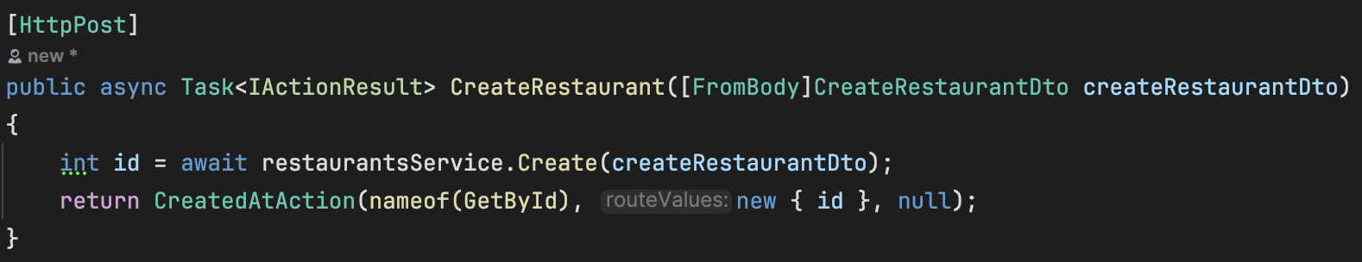
- Create a new dto to create the restaurant data called CreateRestaurantDto.cs
  - This class tells what data the client must send to create a restaurant.
  - Create in Restaurants.Application/Restaurants/Dtos
  - Copy Restaurant and RestaurantDto entity for certain column that we want
  - Make sure public class
  - Make sure to exclude the id part as we want it to be generated automatically
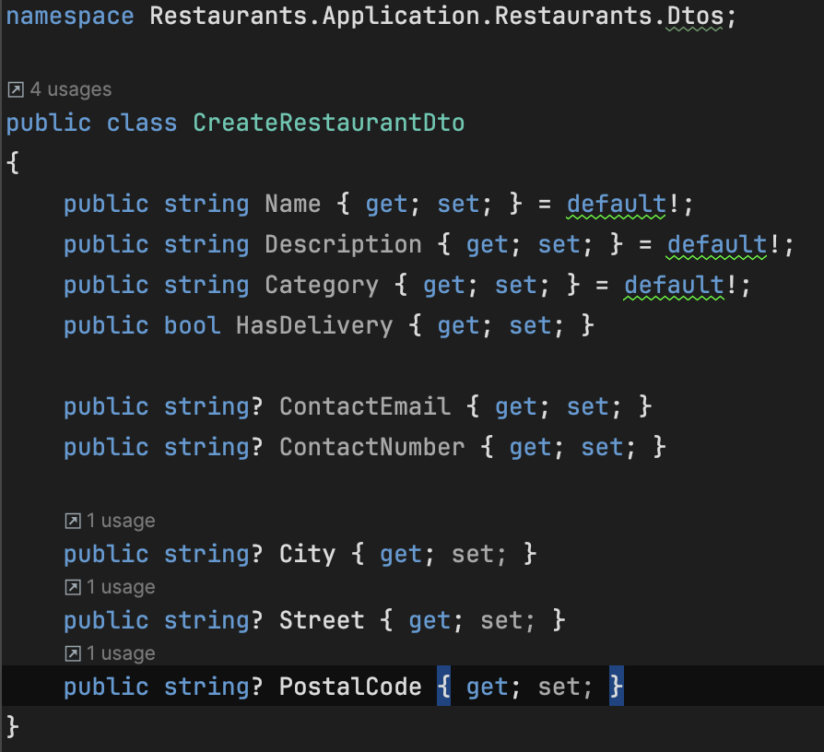
- Edit RestaurantsProfile.cs
  - We use AutoMapper to convert the DTO to actual database entity format
  - Add CreateMap and make sure it maps from CreateRestaurantDto to Restaurant
  - Add ForMember and MapFrom method
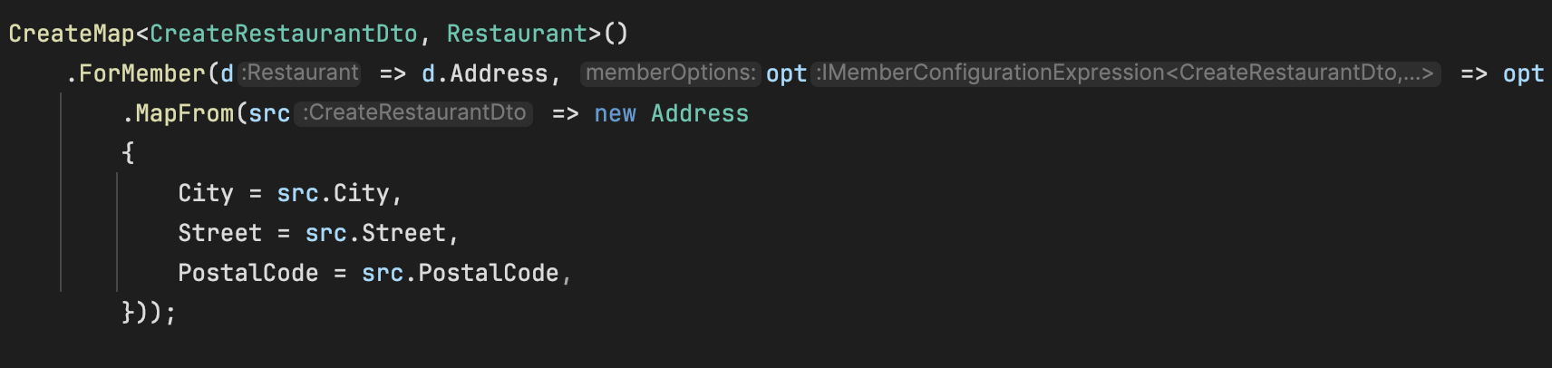
- Edit IRestaurantsService.cs
  - Add Method contract in the service interface
- Edit RestaurantsService.cs
  - Service implementation – business logic
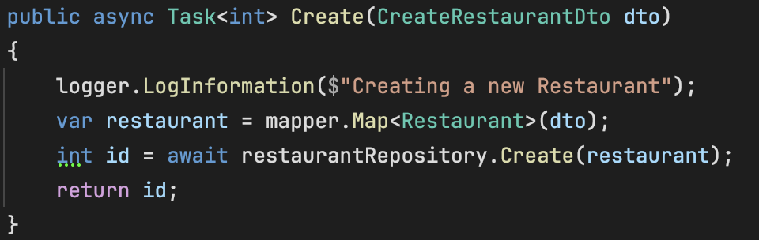

- Edit IRestaurantsRepository.cs
  - Tell system that repository must access DB to create restaurant.
- Edit RestaurantsRepository.cs
  - Actually writes restaurant into PostgreSQL/EF Core
